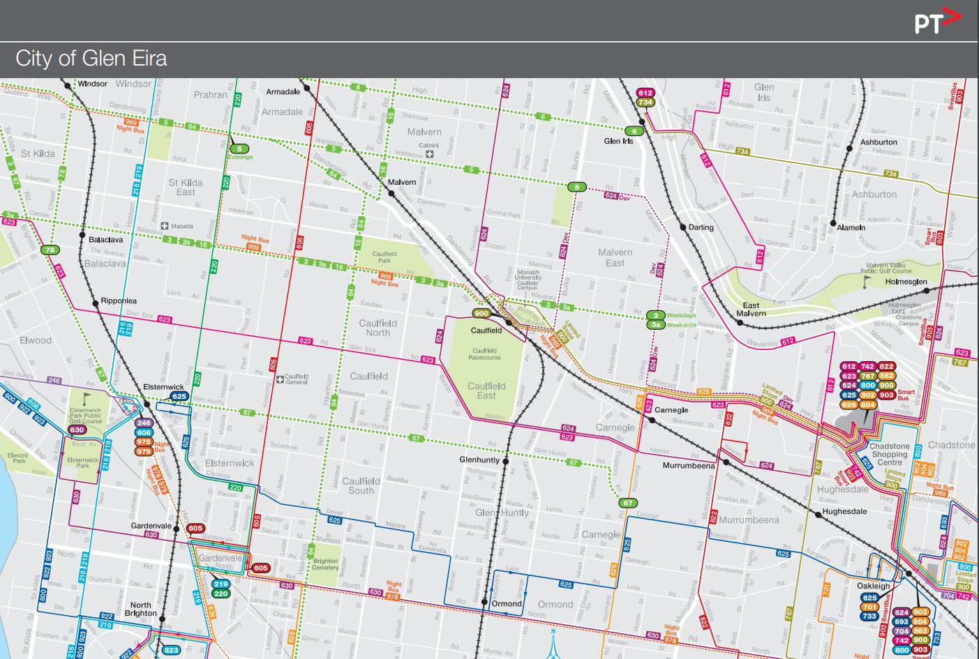

GLEN EIRA COLLEGE TRANSPORT ARRANGEMENTS

Glen Eira College is well served by public transport. The college is close to Caulfield and Glenhuntly railway stations and the Glenhuntly Road tram. Buses pass at the front of the College and provide connections to numerous other modes of transport. Student who ride their bicycles are able to leave them in the bike shed during the school day, although it is essential that students provide a strong padlock and chain to secure their bicycles.

Students who travel by car may be dropped off in Glenhuntly Park off Neerim Road. This is a short walk to the main gates.

A detailed map of the Glen Eira area and transport routes is included.

Bus Route 623 | St Kilda to Glen Waverley via Glen Eira Road. Stops outside the College.
Bus Route 624 | Kew to Oakleigh via Tooronga Road, Caulfield Station, Booran Road, Neerim Road, Poath Road, Chadstone. Stops outside the College.
Tram 67 | Is only 5 minutes from the College. It connects with Chapel Street trams 78 & 79 and with transport in Carnegie area and further east.
Students in the Prahran area can catch a train from Prahran or Windsor stations (Sandringham Line) and alight at Elsternwick station. They then catch the 67 tram as above.
Bus Route 623 and Tram 67 connect with the Bus Route 220 (Orrong Road), Bus Route 216 (Hotham Street/Williams Road) and Bus Route 605 (Kooyong Road).
Glenhuntly Railway station | The station is a ten minute walk to the College
Caulfield Railway station | The station is a twenty minute walk to the College.

